TCL Scripting:

VMD includes support for Tcl scripting; anything that can be done in VMD’s graphical user interface can also be done in Tcl via the Tk Console. Under “Extensions”, select “Tk Console”; this opens a new window where you can type Python and Tcl commands. Code input lines in the lab will be marked with %, while output lines will be displayed in this font without anything preceding the line. Do not enter the percent sign into the Tk Console! Some examples are
% set variable value # assign value to variable
% puts $variable # output the value of $variable. Note the $ sign.
% expr {expression} # evaluate the mathematical expression. {} is not necessary.
You can use the up arrow to copy what you entered in a previous line to your current line.

Then you need to learn how to use different kinds of braces.
- First and foremost, it important to remember that everything you type as a Tcl command is essentially a string, despite that they may look like numbers, etc.
- All kinds of braces have the effect of giving the content inside priority upon evaluation – just like the braces in mathematical expressions.
- Square brackets [] replace the embraced expression with the value it returns, i.e., force its evaluation.
- Curly braces {} group the entire expression inside. It is necessary when your expression has spaces. Pay attention to the following example which shows that the only curly braces do is grouping its content.
- Double quotes “” perform almost the same functionalities as curly braces, but with one thing more: they also substitute the value for the variable. Note that it is easy to expect curly braces to be a string-marker; however, because Tcl treats everything as a string, the true functionality of double quotes has nothing to do with “stringifying.” For example, the line of code puts “Hello!”, puts {Hello!}, and puts Hello! have the exact same result. Nonetheless, it will make the code more readable if you enclose what you expect to be a string with double quotes.

For example:
% set myvar 5
5
% set x 3
3
% expr {$myvar * $x}
15
% set result {7 + $myvar ** $x}
7 + $myvar ** $x ($result does not store a number!)
% set result [expr {7 + $myvar ** $x}]
132
% puts “The value of result is: $result”
The value of result is: 132

Writing Files
To write to a file, you first need to associate a variable with the file, and then you can use the puts command to write to it.
% set file1 [open "testfile.txt" w]
% puts $file1 "This is the first line."
% puts $file1 "This is the second line."
% close $file1

For Loops
For loops allow you to repeat an action until a pre-determined stopping point. In Tcl, the syntax is:
% for {initialization} {test} {increment} {commands}
A variable is initialized, and each time the loop is run, it is incremented. The loop repeats while the test condition remains true, or else it stops execution and moves on to the next line of code after the loop. The following example prints out each number from 1 to 15 on a separate line:
% for {set i 1} {$i <= 15} {incr i} {puts $i}

The command below measures the distance between two atoms
measure bond {<atom1_index> <atom2_index>}

For example: measure bond {2 10} measures the distance between atom 2 and 10
Note that it may seem weird that curly braces both group math expressions and represents a list (of atoms indices here). Please remember that the only thing that curly braces do is to group the content within. Whether it is parsed into a list, a command, a math expression, or so on depends on its context.

We can obtain the list of atom indexes of an atom selection:
set sel [[atomselect top “all”] list]
Since sel is already a list, there is no need to use {} in measure bond.

llength: returns the length of a list
% llength {1 2 3}
3
lindex: returns item at given index
lindex {1 2 3} 1
2

Essential commands:
- Set value
- Puts $variable
- Expr {expression}
Finding the atoms of a residue:
- set sel [[atomselect top "resid 152"] list]
- set sel [[atomselect top "(resid 153) and (name N)"] list]
Updating frames:
- set sel1 [atomselect top "$seltext1"]
- $sel1 frame $i
- $sel1 update
For loop:
- for {set i 1} {$i <= 15} {incr i} {puts $i}
Measuring stuff:
- measure dihed {2188 2190 2192 2202}
  - Psi angle: N – Cα – C – N (of residue i+1).
  - Phi angle: C (of residue i-1) – N – Cα – C
- measure hbonds cutoff angle selection1 [selection2]
  - returns 1. Indices of the donors 2. Indices of the acceptors 3. Index of the hydrogen atom in the hydrogen bond.
- measure hbonds 3.2 30 [atomselect top "all"]]
- measure angle {3214 3253 3252}
- measure minmax $sel
  - $sel is chosen as [atomselect top "all"] here.
  - Measures the boundaries.
- measure rmsf $sel first 0 last $nframes2
  - Note: If the parameter is optional, you need to specify it.
- Measuring the distance of stuff:
  - set com1 [measure center $sel1 weight mass]
  - set com2 [measure center $sel2 weight mass]
  - set dist [veclength [vecsub $com1 $com2]]
Making a list as a variable (note: It selects the atom on top, i.e. marked with a “T” in VMD):
- [atomselect top "all"]
Getting the item an array:
- lindex [measure hbonds 3.2 30 [atomselect top "all"]] 1]
- set rmsf [lindex $rmsfCA $i]
Finding the length of an array:
- llength [lindex [measure hbonds 3.2 30 [atomselect top "all"]] 1]
Moving stuff:
- $sel moveby [vecinvert $coords]
- $compare move $trans_mat
Centering a cube of molecules:
- set sel [atomselect top "all"]
- set coords [measure center $sel]
- $sel moveby [vecinvert $coords]
- $sel writepdb 1UBQ-solvated-ionized-centered.pdb
Saving to PDB:
- $sel writepdb water_box_centered.pdb
Getting dimensions:
- pbc get
Files:
- Open file: set file1 [open "testfile.txt" w]
- Write file: puts $file1 "This is the first line."
- Close file: close $file1
Printing strings:
- set result [expr {7 + $myvar ** $x}]
- puts “The value of result is: $result”
Getting number of frames:
- Molinfo top get numframes
- Molinfo $mol get numframes

Angle measuring easy code:
set sel1 [[atomselect top "resid 69 and name CB"] list]
set sel2 [[atomselect top "resid 69 and name N"] list]
set sel3 [[atomselect top "resid 69 and name CA"] list]
set sel4 [[atomselect top "resid 70 and name CB"] list]

Directory to go to:
/Users/harrywang/Documents/BIOS\ 10603/MultiScale-Winter26-Lab5

Centering:
- set sel [atomselect top all]
- set coords [measure center $sel]
- $sel moveby [vecinvert $coords]
- $sel writepdb 1UBQ-solvated-ionized-centered.pdb
Restraining:
- set sel [atomselect top “protein and backbone”]
- $sel set beta 10
- set sel [atomselect top all]
- $sel writepdb XXXX-restrain.pdb

Unwrapping:
- pbc unwrap -first 0

Plotting stuff in R:
infile = read.table("./hbonds.dat", header = T, sep = " ")
colnames(infile) <- c("frame", "count")
mean(infile[["count"]])
plot(infile$frame, infile$count, type = "l", xlab = "Frame", ylab = "# of H bonds", ylim = c(0, 19000))

Other VMD Stuff:

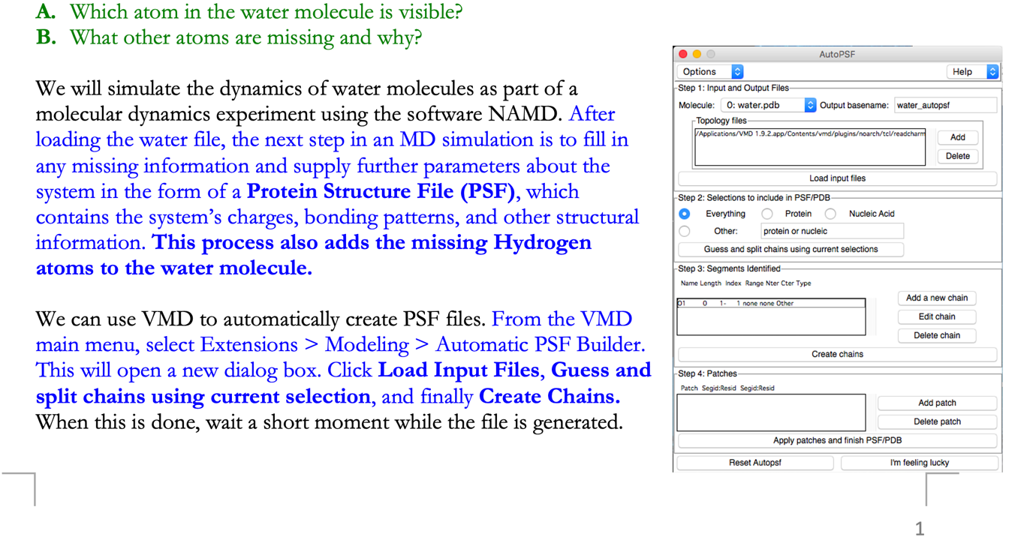

Sample Batch file:
#!/bin/sh
#SBATCH --job-name=name_me
#SBATCH --output=
#SBATCH --time=00:00:00
#SBATCH --exclusive
#SBATCH --partition=caslake
#SBATCH --nodes=0
#SBATCH --ntasks-per-node=48
#SBATCH --account=
module load namd/2.14
mpiexec.hydra -bootstrap=slurm namd2 "configuration-name.conf" > "configuration-name.log"

